**University of Petroleum and Energy Studies**

School of Computer Science

Department of Cybernetics



**Graphics & Animation Tools**

**LAB FILE**

**(Session: 2020-2021)**

Course: B. Tech with Specialization in Open Source and Open Standards

Batch: 2017-2021

Semester: VIIth

**Submitted By: -**

Nikhil Mishra

Roll No: R100217043

SAP ID: 500062584

**Submitted To: -**

Dr. Durgansh Sharma Assistant Professor

Department of Cybernetics

**Experiment- 9** Design of 3D Mountain Landscape using Blender.

In this experiment we need to create a 3D Mountain Landscape of our choice with the help of blender.

1. Clear your default interface of blender which includes deletion of cube.
2. Press Shift + A and go to landscape, and create a landscape on the screen
3. Change the properties of landscape according to your need and provide more realistic shape and view for a mountain
4. For creating field view in front of mountains, we can take the plane surface in front of the mountain, and extrude at a few places to give it a look of rough surface.
5. Take a few cubes on the plane and extrude its surface from a few places to give it a shape of rocks
6. For creating trees in the field take a cone and extrude its side from all direction to give it a shape branch.
7. Copy the step-7 and create multiple little trees in the fields for better look.
8. Now for the colouring part, go into the edit mode again, and select the faces you want for one colour, and click the + button in the materials section
9. This will apply the colour to all faces, next click on another face, click the + button, and click Assign, this will give the selected face the new material.
10. Finally export your files as .blend file and also render a few images for the reference purpose.

**OUTPUT:**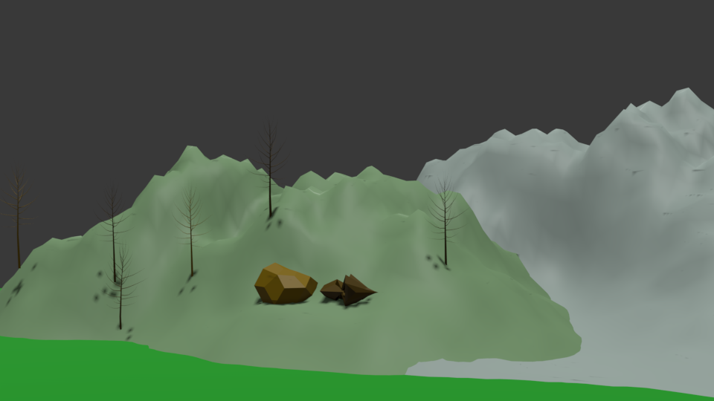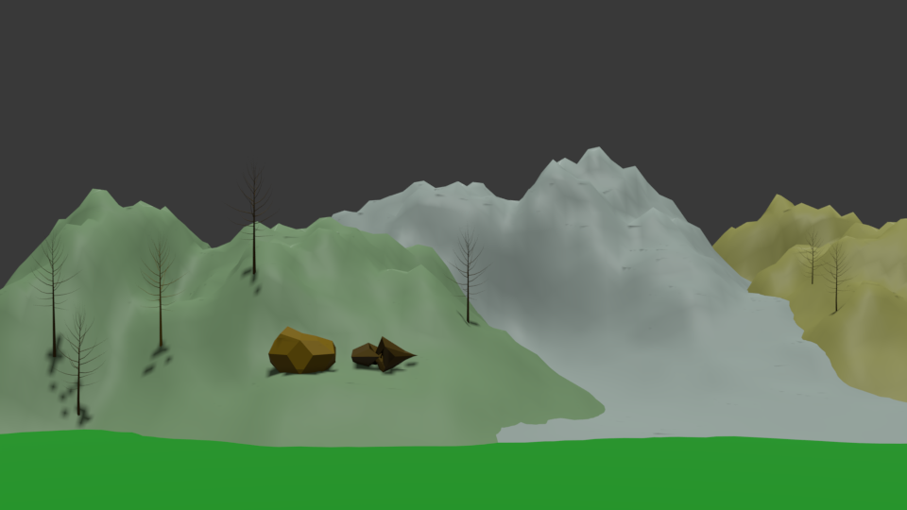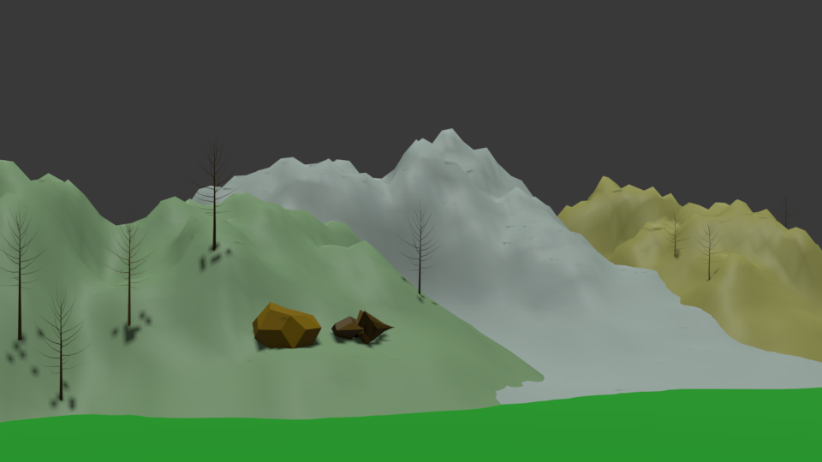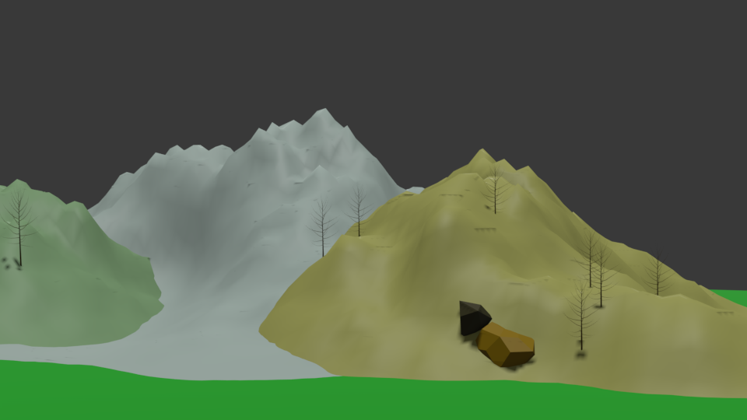

**Google Drive Link:** [**https://drive.google.com/drive/folders/18C0VtIAk-awUy3Axst3degZLR7YdXza2?usp=sharing**](https://drive.google.com/drive/folders/18C0VtIAk-awUy3Axst3degZLR7YdXza2?usp=sharing)